* Create ec2 instance to install Jenkins

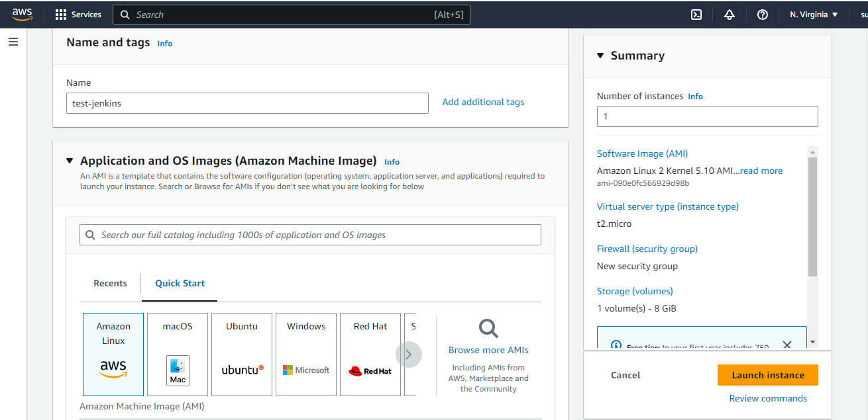

* Launch instance

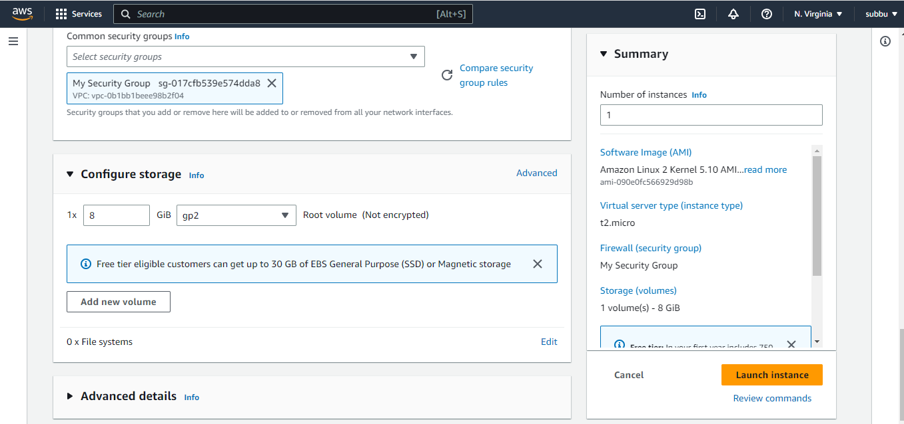

* Goto ssh terminal like mobaxterm and run instance

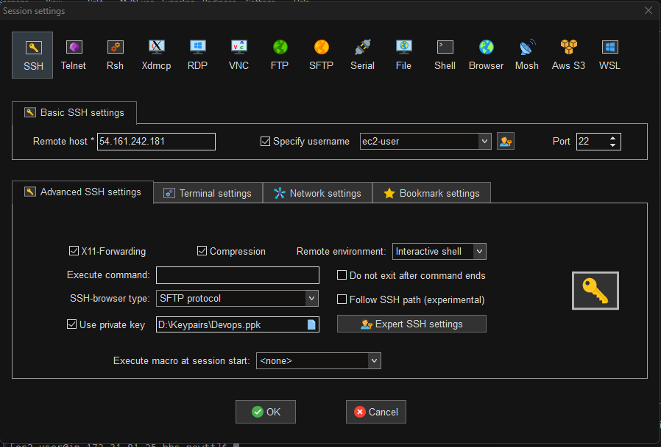

* Ensure that all software packages are upto date for that run sudo yum update

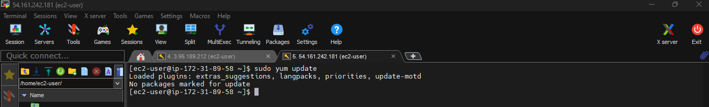

* Add the Jenkins repo using the following command:

**[**ec2-user ~]$ sudo wget -O /etc/yum.repos.d/jenkins.repo \

<https://pkg.jenkins.io/redhat-stable/jenkins.repo>

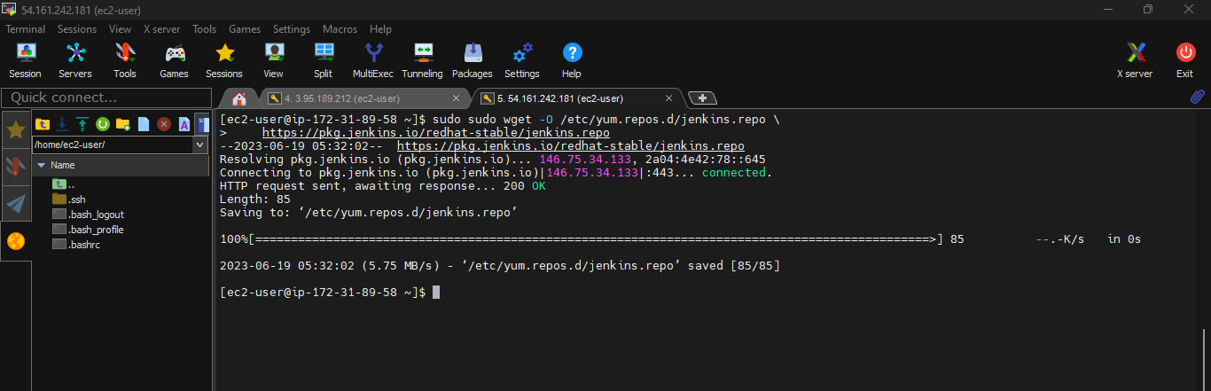

* Import a key file from Jenkins-CI to enable installation from the package:

sudo rpm --import https://pkg.jenkins.io/redhat-stable/jenkins.io-2023.key

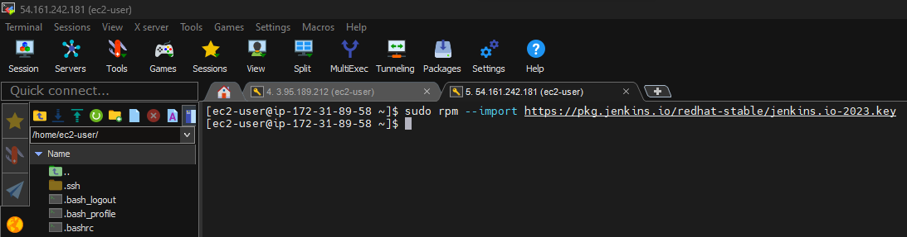

* Update

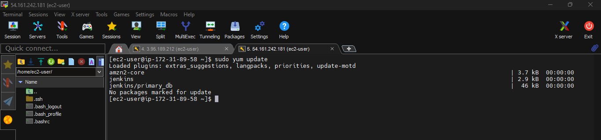

* Install java

sudo amazon-linux-extras install java-openjdk11 -y

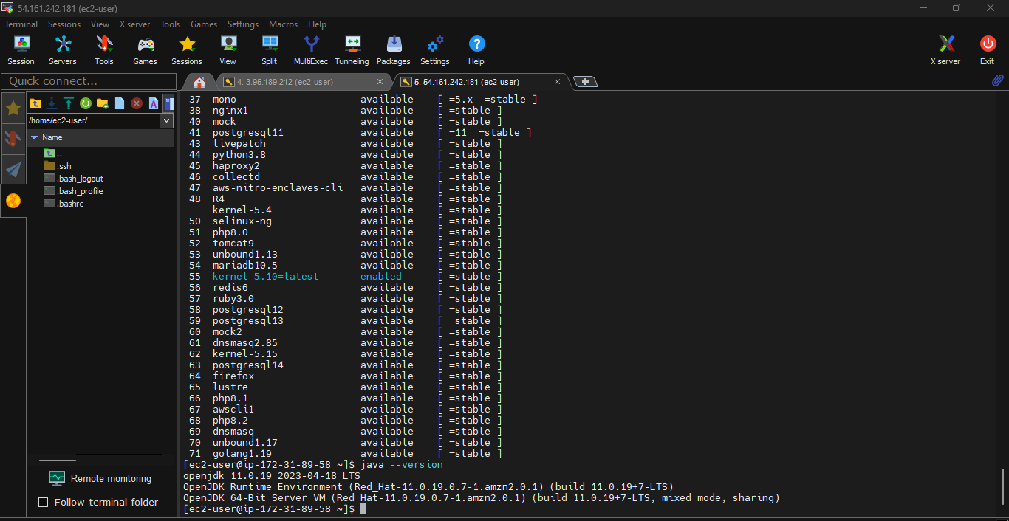

* Install Jenkins

sudo yum install jenkins -y

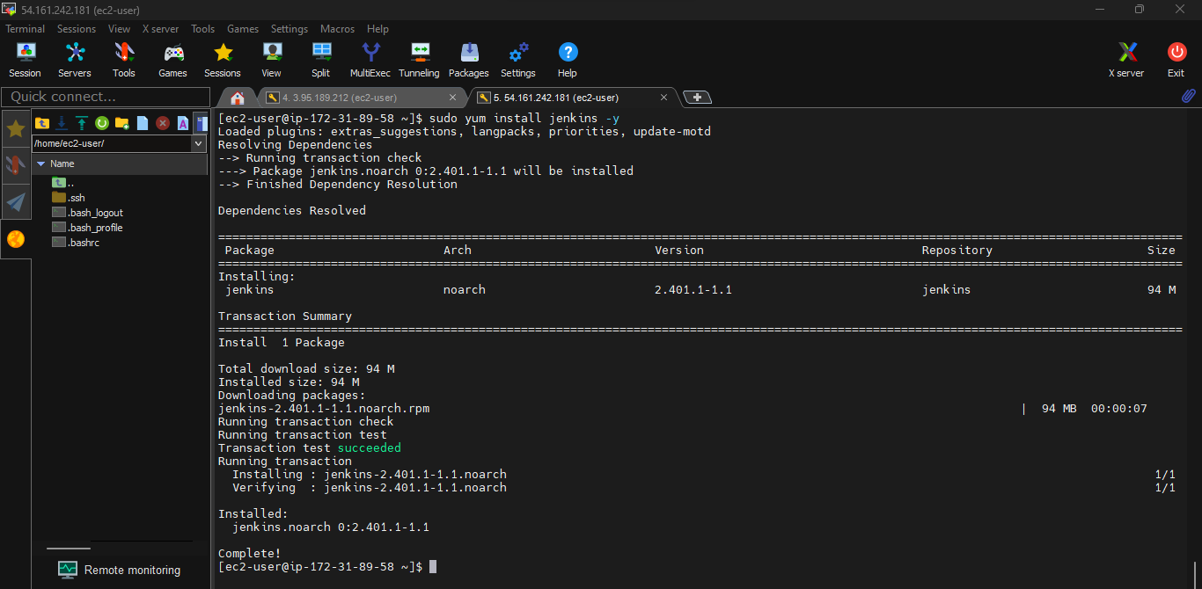

* Enable the Jenkins service to start at boot:

sudo systemctl enable jenkins

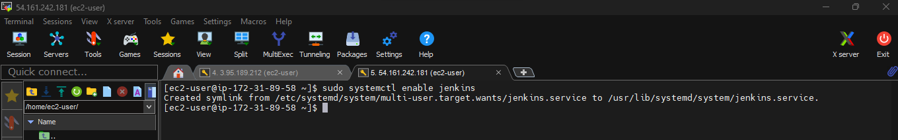

* Start Jenkins as a service

sudo systemctl start Jenkins

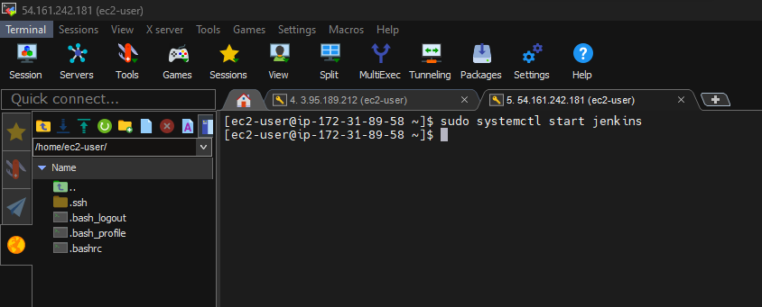

* Check Jenkins Status

sudo systemctl status Jenkins

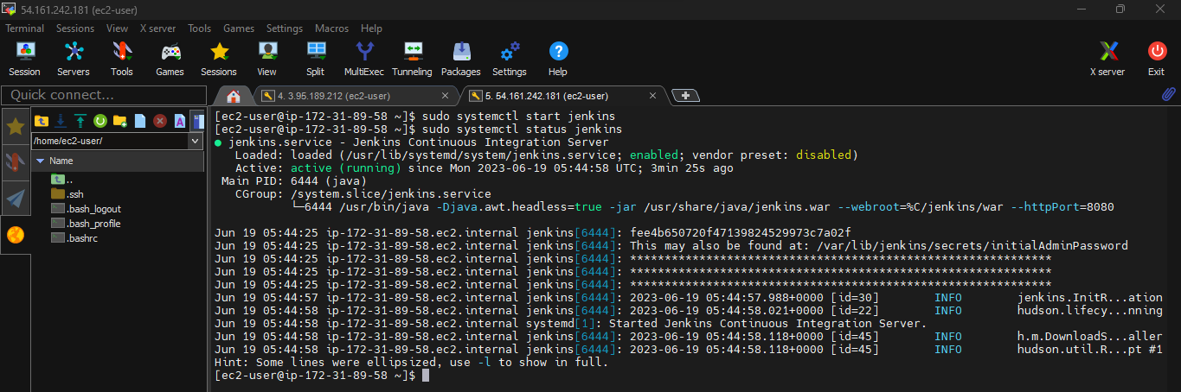

* Copy the public ip from the instance

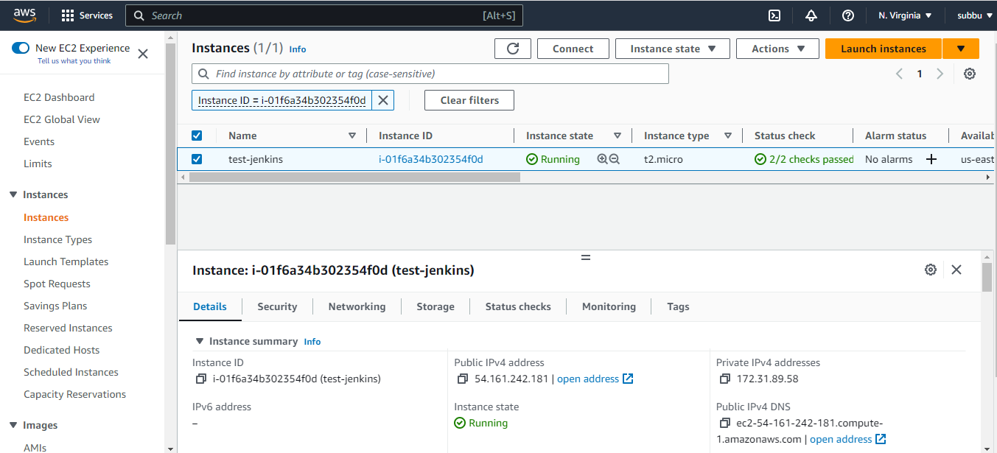

* To the Ip address add Jenkins port number 8080

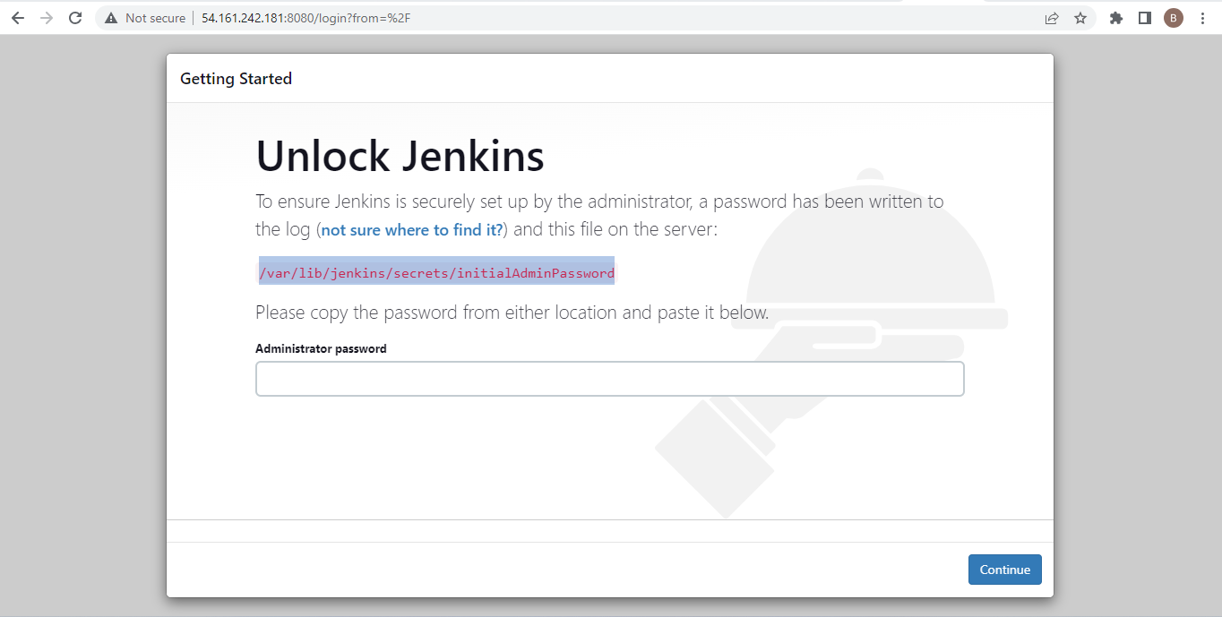

* Goto root user and and check the admins password to unlock Jenkins

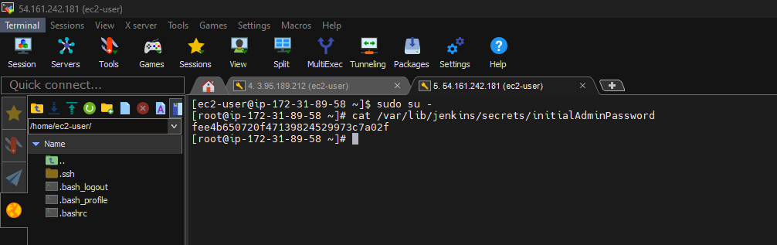

* Now copy the password and paste, click continue

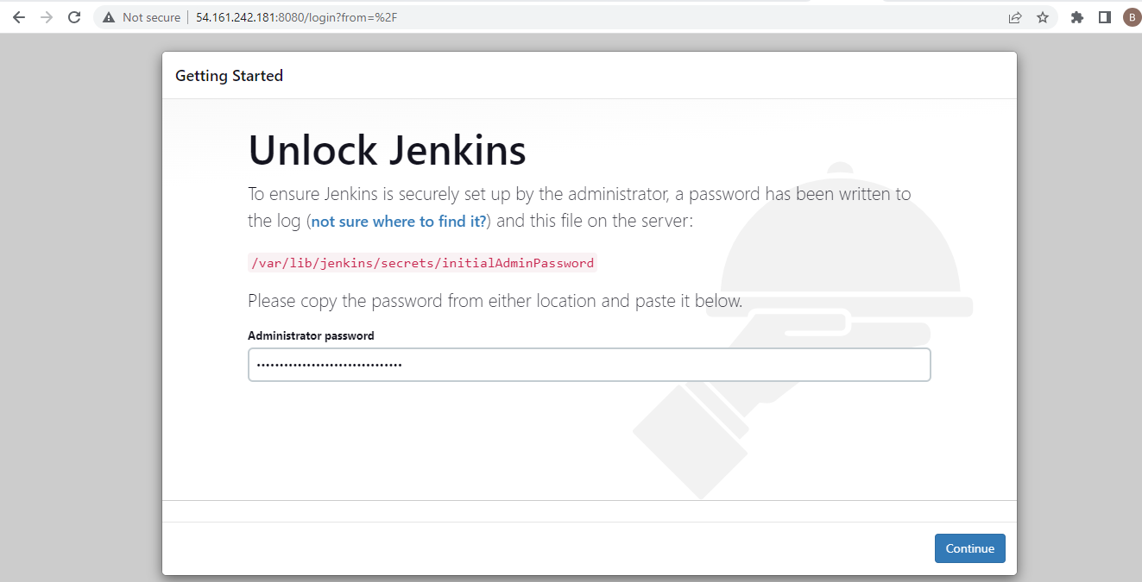

* Now we get the page Customize Jenkins, select install suggested plugins

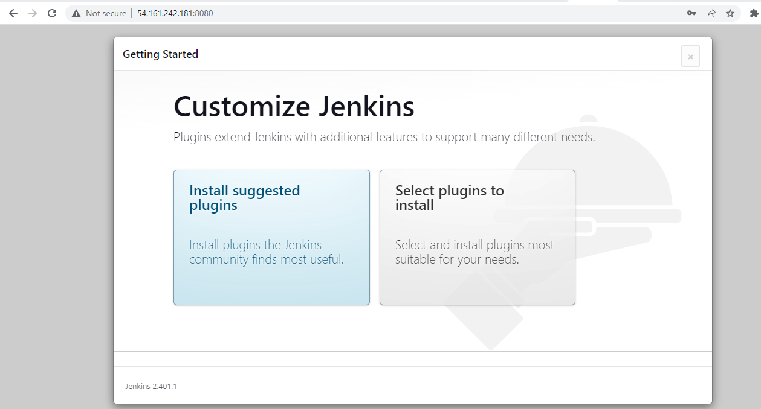

* Create user

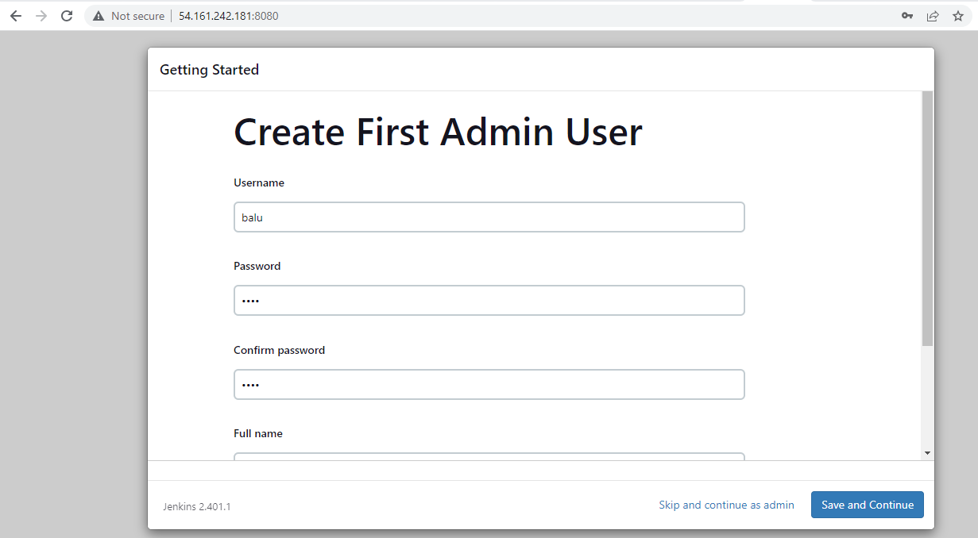

* Save and finish

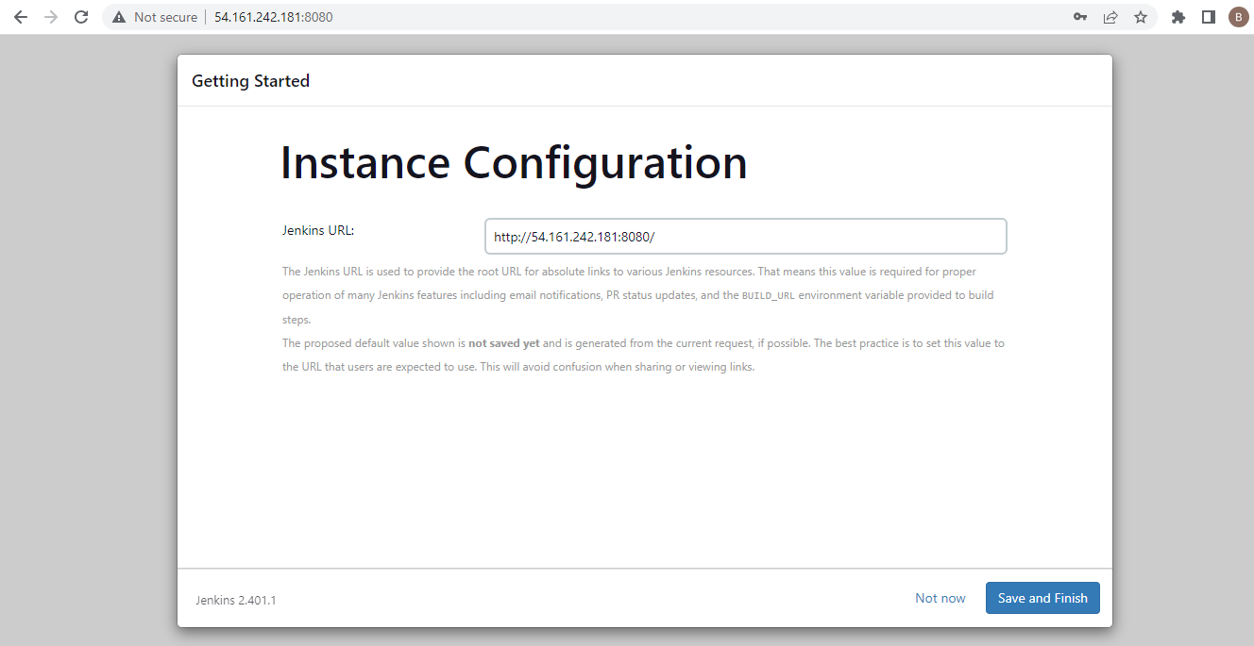

* Jenkins is ready

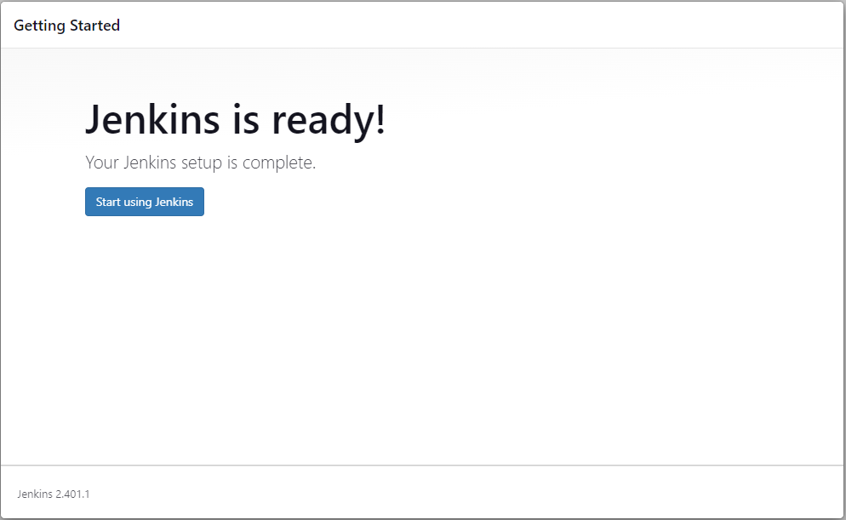

* Now the Jenkins Main page

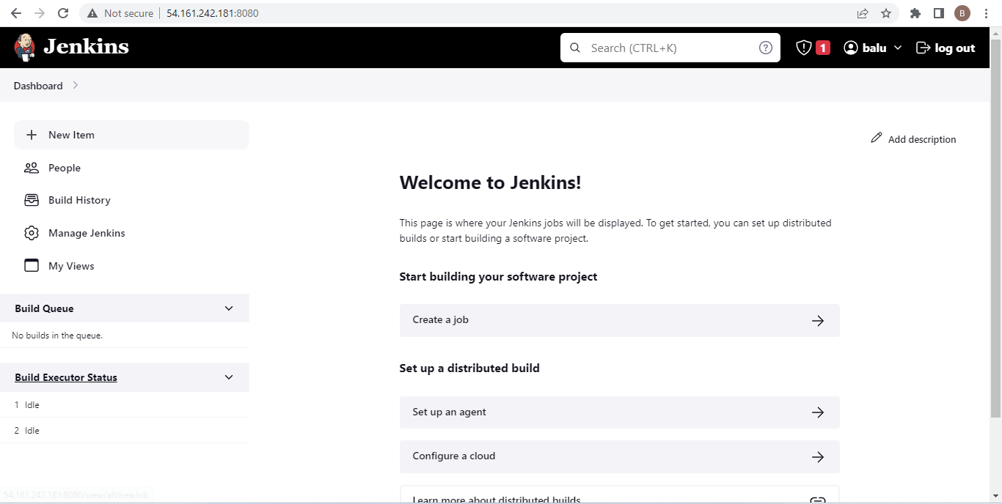

*Creating EC2 instance using Terraform through Jenkins*

* Click on new item

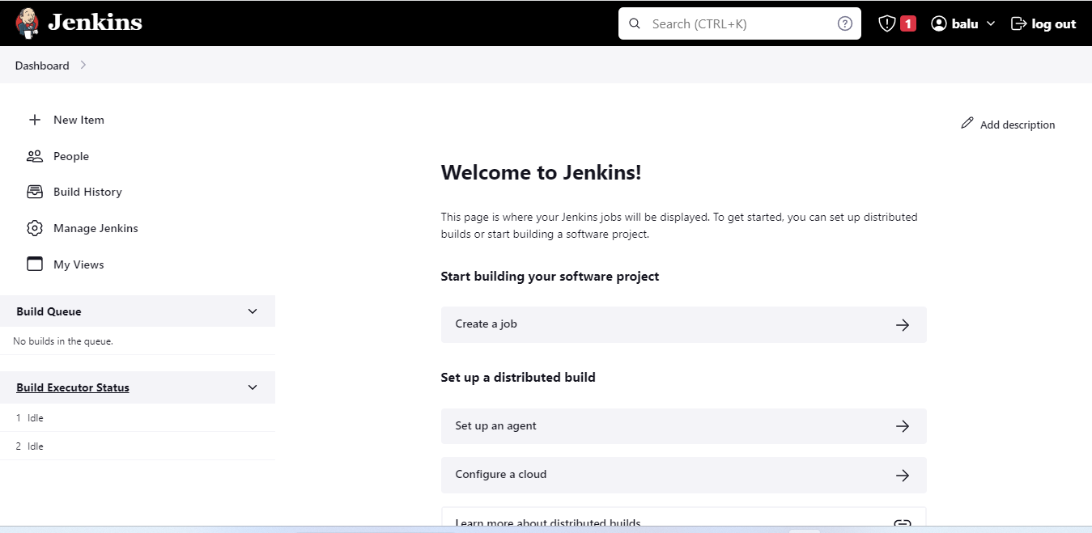

* Select Freestyle project and give name to the project

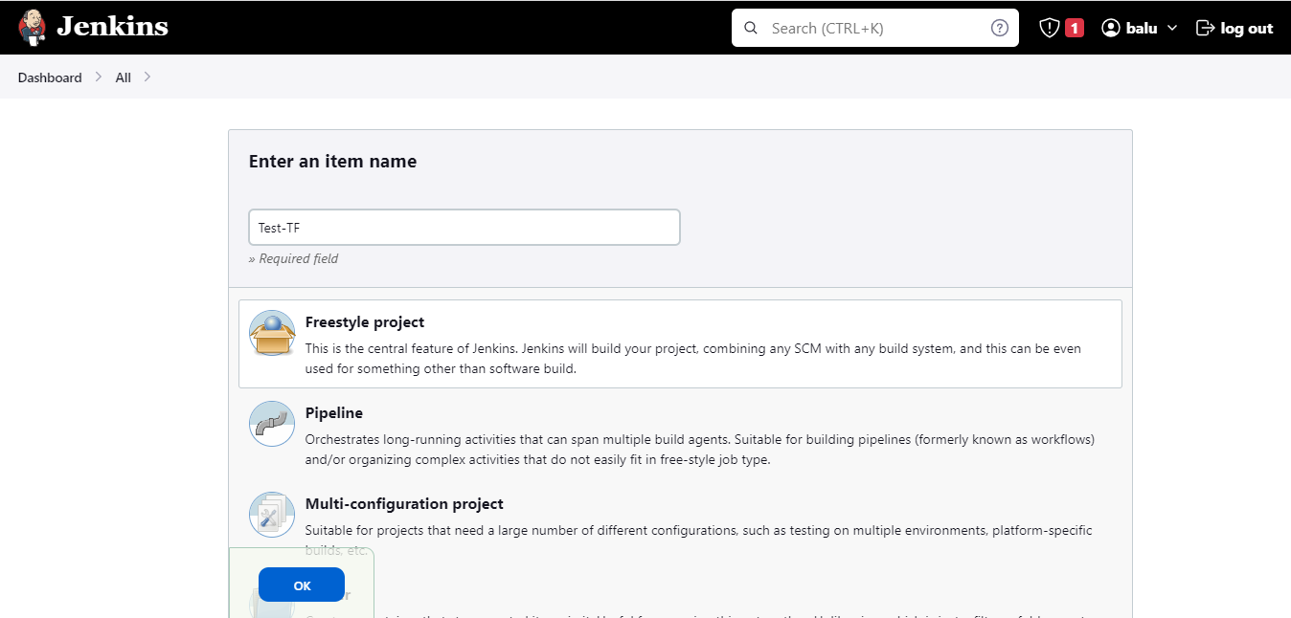

* Copy the git repo code and paste in the repo URL

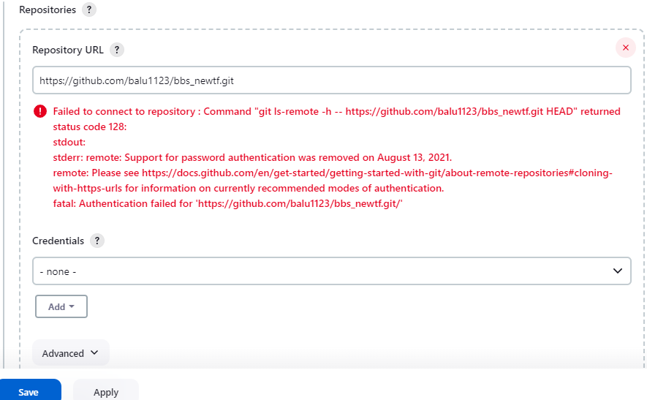

* Now give git credentials (because the gitrepo is in private) where the terraform code is saved.

Click on add and click on Jenkins

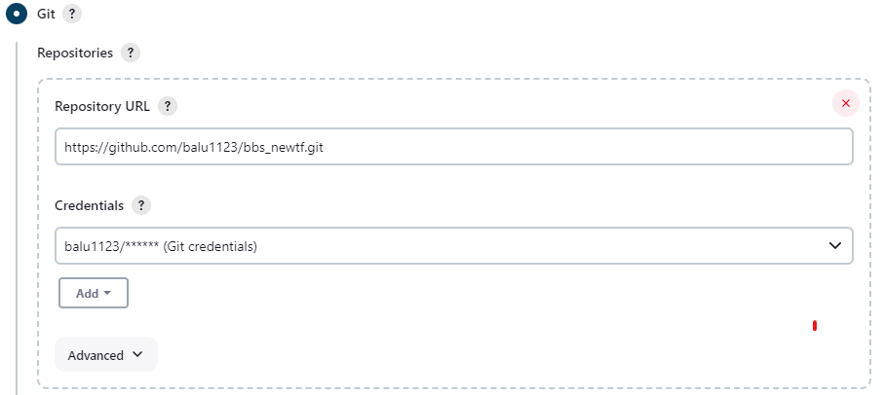

* Check the git branch and name the branch according to your git repo

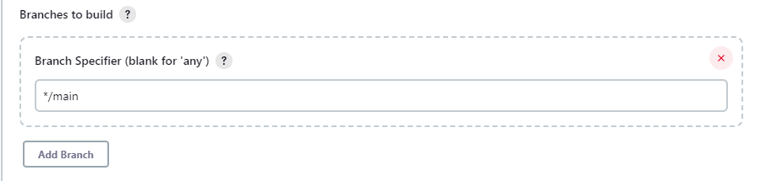

* Goto Build steps and select execute shell

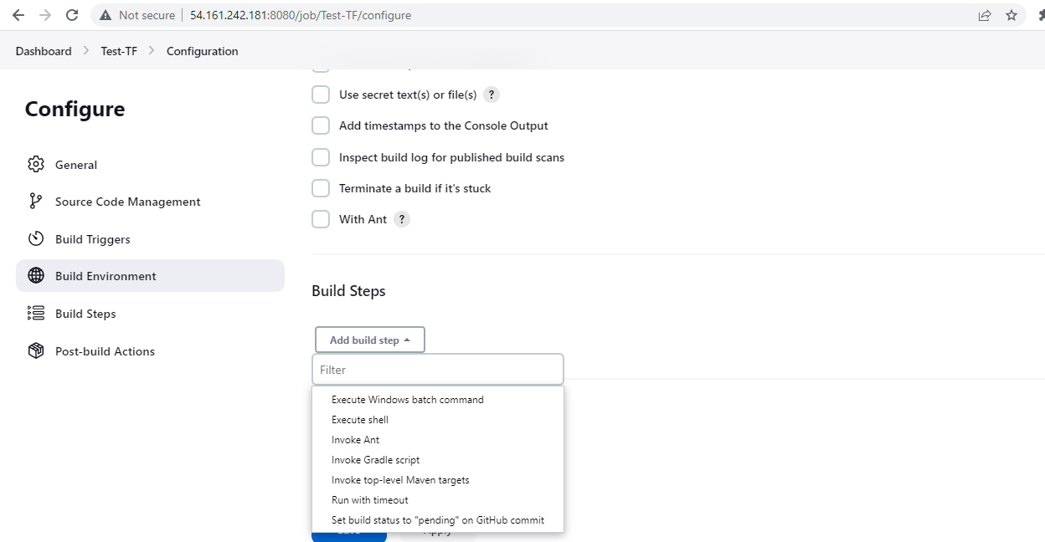

* Now type the executing script (which comes under user data in EC2 instance)

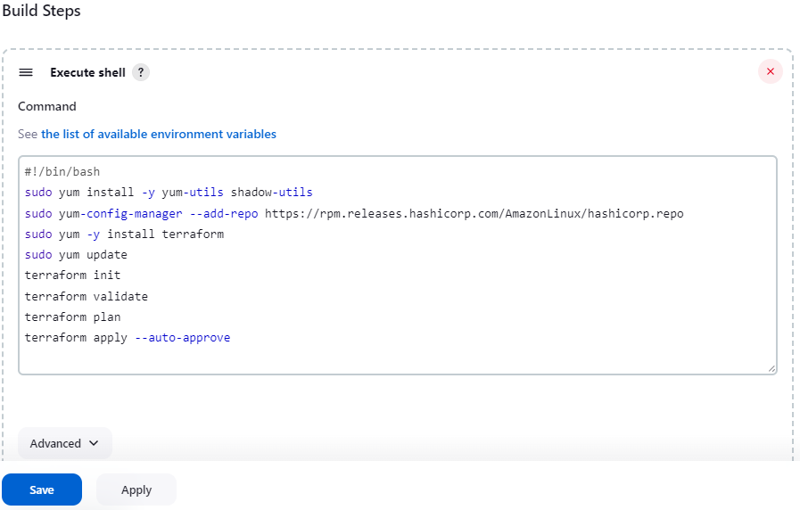

Click apply and save

* Now click on “Build now”

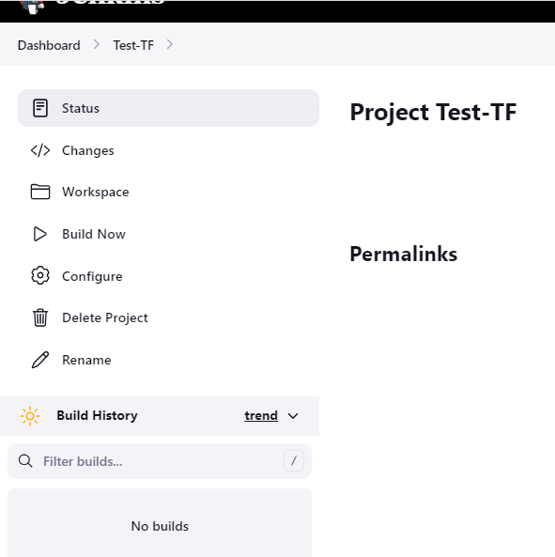

* We get an error



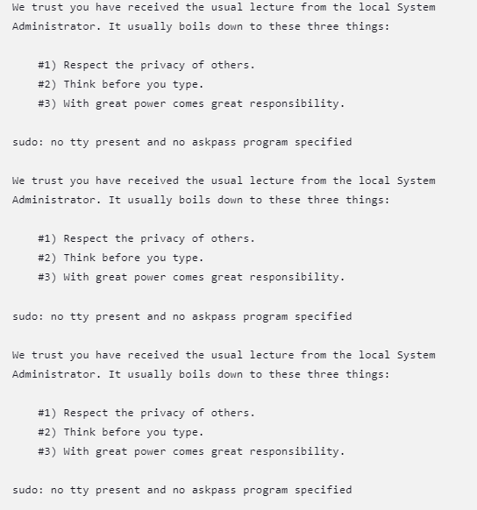

* To solve this error switch to root user and goto /etc folder and edit sudoers file

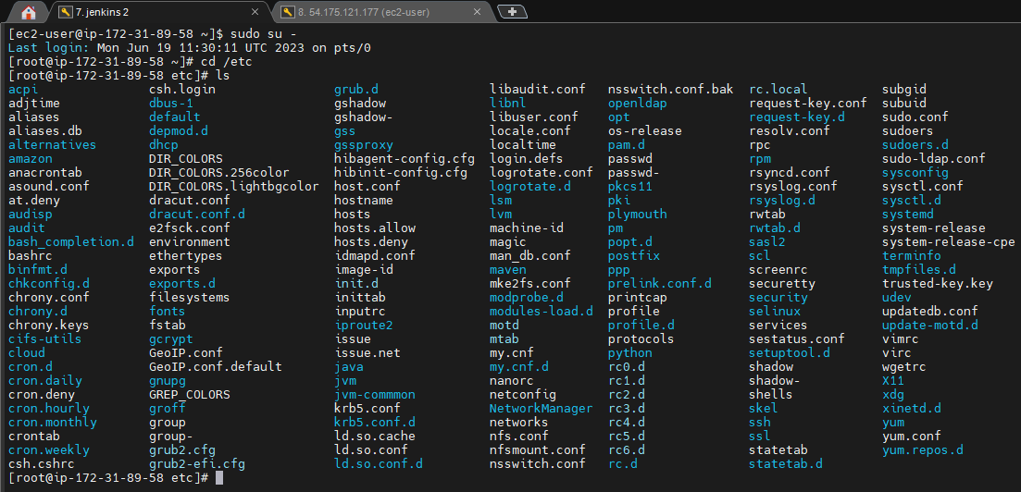

* In sudoers file add - jenkins ALL=(ALL) NOPASSWD: ALL

Under - ## Allow root to run any commands anywhere

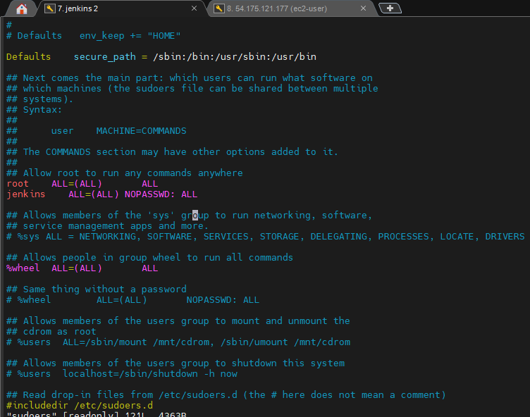

* Build again

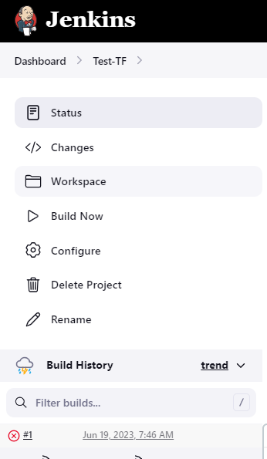

* Check the console output

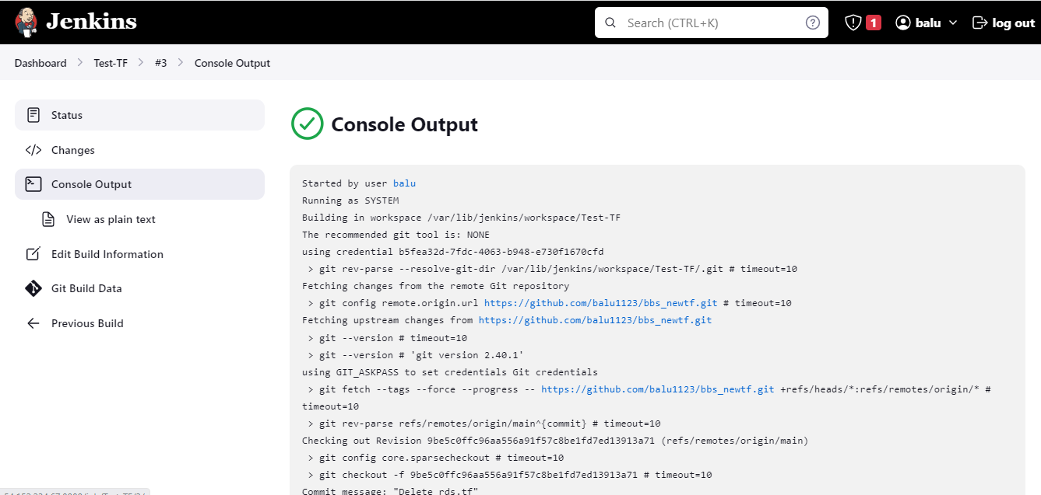

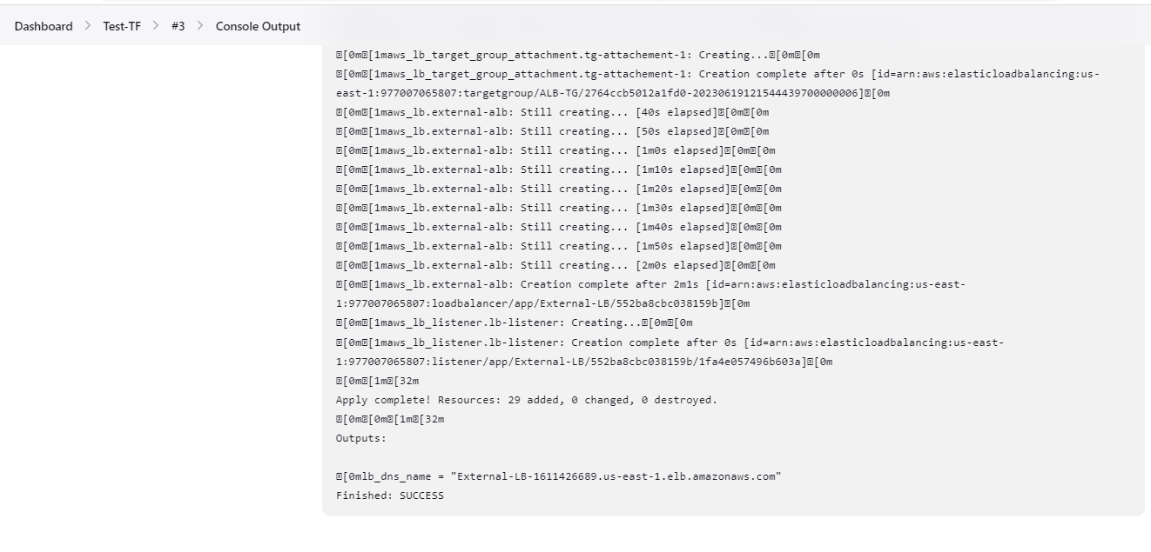

* Now check the AWS console whether the resources created or not.

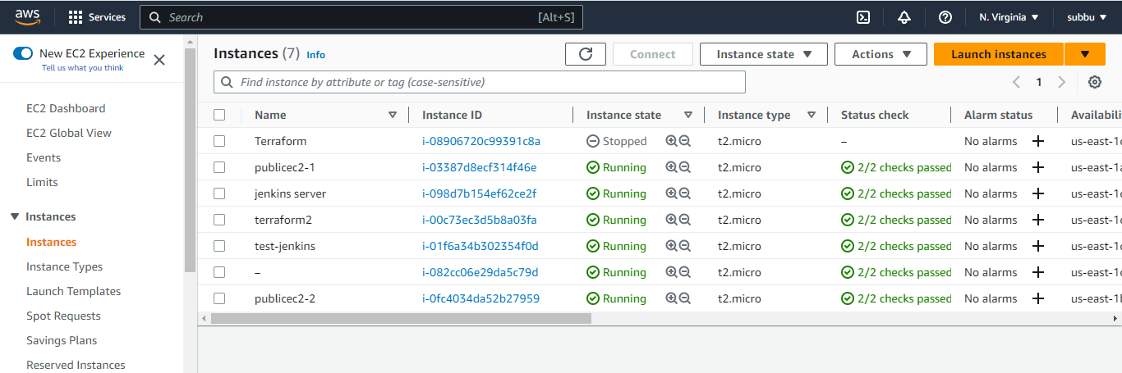

* VPC created

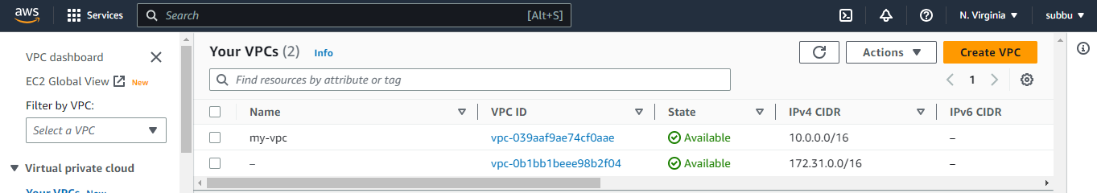

* Subnets created

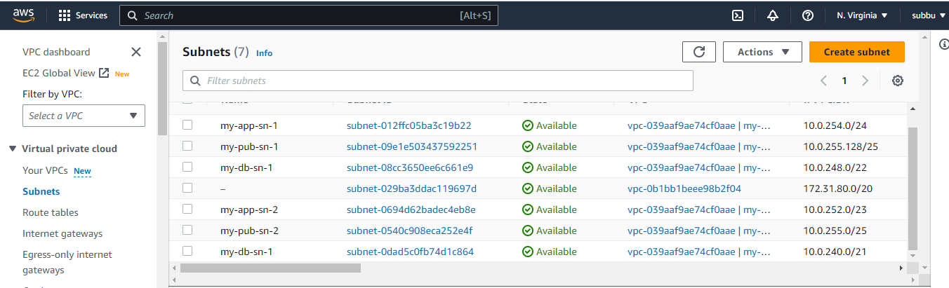

* Public route table and subnet associations

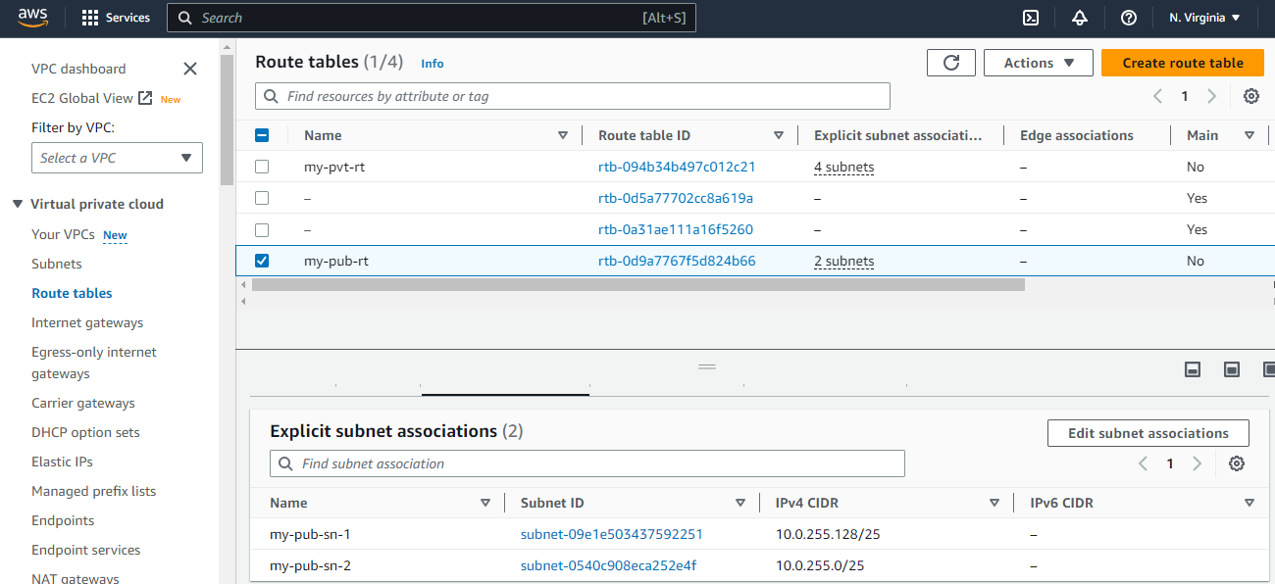

* Private route table and subnet associations

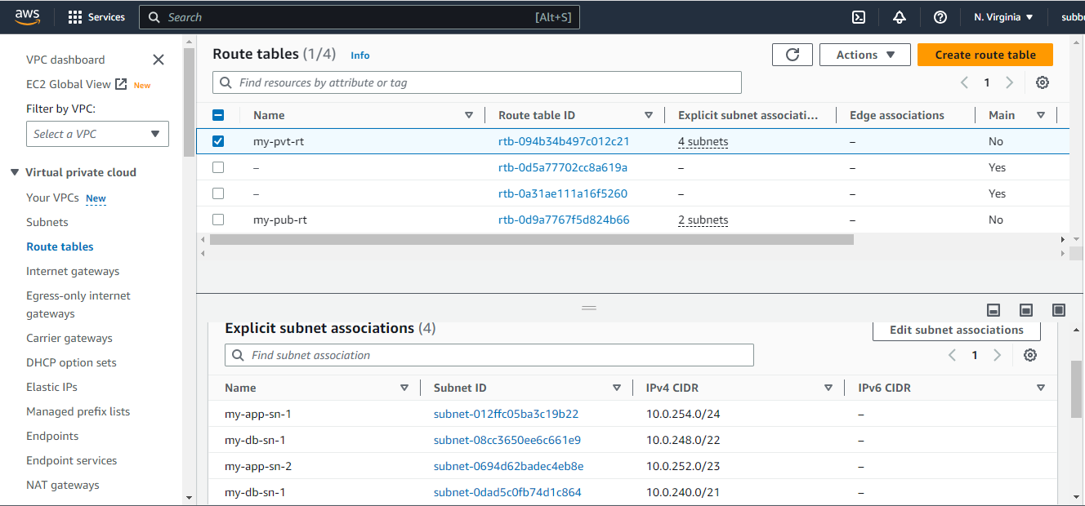

* IGW created

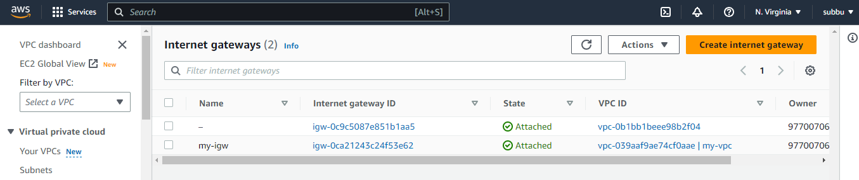

* Security groups created

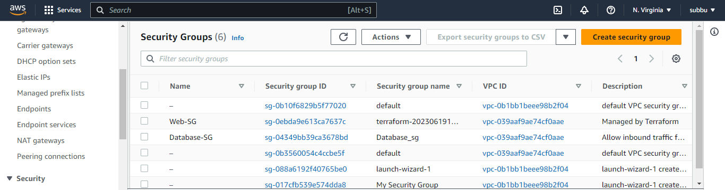

* Load Balancer created

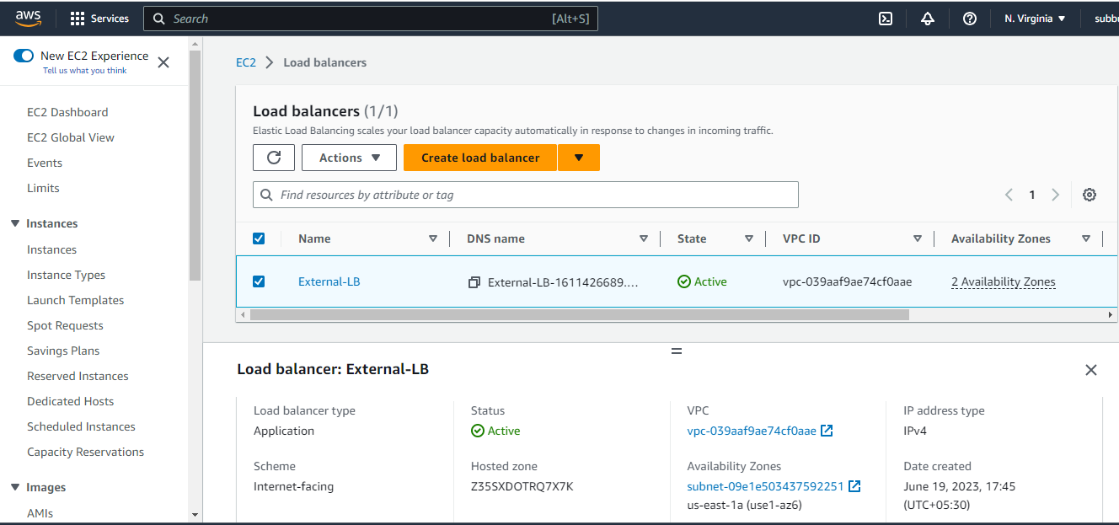

* Target group created and the instances are Healthy

